Hoang Vu Hai CIT381_001

1. What version of NOOBS did you download and install on your Raspberry Pi?

I installed with the version that my raspberry pi kit came with, version 10

2. What issues, if any, did you encounter with the installation of Raspian?

I encountered a small issue running the script, but the fault is entirely on me for not setting up my email correctly.

3. What password did you use for the pi account on your Raspberry Pi?
The password is Bimbim1?

4. Run ntpq -c rl at the command line. What stratum is it?
stratum is 16

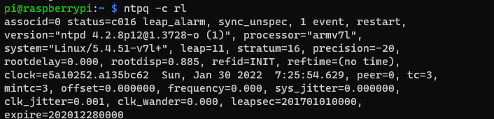
5. What does stratum refer to in ntp? You will need to research this.
NTP is short for Network Time Protocol
It is an internet protocol to synchonize the clocks of computers.
In NTP, time is synced from a high precision device to lower precision devices. Stratums reflect this heirarchy via the 15 stratum levels with Stratum 0 to 15 from most precise to least(as these devices encur delays and errors due to being synced further away from the source).
My stratum level is 16, which is a level reserved for devices that don’t have their time synced at all or it thinks it is not synced to a reliable timesource.

6. Copy and paste the email you receive with the Raspberry PI's IP address.

The IP address of the Raspberry PI is: 10.15.8.211 its hostname is raspberrypi

7. Reflection
Write a brief reflection. This should be a paragraph or two in which you reflect on your
lab experience. Discuss items such as the following:
• What was the most valuable feature of the lab?
• How did you prepare for this lab? What changes are you considering in preparing
for your next lab?
• What did you learn from this experience?
• What advice would you give someone who was preparing for this lab for the first
time?
Don't think of the reflection as a question/answer section. This should be well-written
paragraph or two that discusses items like those listed above.

The most valuable thing that I have learned from this lab is the importance of attention to detail. The lab would have been completed without a hitch if I had followed the instructions more carefully. I prepared by bringing all the equipment that I purchased for this class to the lab. I am thinking about only bringing the Raspberry Pi and running it headless next time while using my laptop to SSH or VNC to my PI. This way, I don’t have to bring around clunky keyboards, mice, and the monitor that doesn’t sit flush in my bag with me. I learned a lot about the raspberry pi from this lab. I tried not to tinker with it too much and spoil myself before the class. The raspberry pi is such an amazing and useful device and would be perfect as a small pastime personal project. Finally, if I were to give someone who was preparing for this lab I would recommend that they install the OS before coming to class. Additionally, it would be very beneficial to learn beforehand how to run the device in headless mode. This will help reduce the complexity of having keyboards, mice, and monitors.

